- (a) A simple pendulum may be used to determine a value for the acceleration of free
fall g. Measurements are made of the length L of the pendulum and the period T
of oscillation.
The values obtained, with their uncertainties, are as shown.
T = (1.92 ± 0.02) s
L = (91 ± 1) cm
(i) Calculate the percentage uncertainty in the measurement of
1. the period T,

uncertainty = ……………..…. % [1]
2. the length L.

uncertainty = ………….……. % [1]

(ii) The relationship between T, L and g is given by
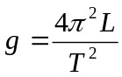
Using your answers in (a), calculate the percentage uncertainty in the value
of g.

uncertainty = …………….…% [2]
(iii) The values of L and T are used to calculate a value of g as 9.745 m s^{–2}.
By reference to the measurements of L and T, suggest why it would not be
correct to quote the value of g as 9.745 m s^{–2}.
..……………………………………………………………………………
…..…………………………………………………………………… [1]

(b) An object is acted upon by two forces at right angles to each other. One of the
forces has a magnitude of 5.0 N and the resultant force produced on the object is
9.5 N.

Determine
- the magnitude of the other force,

force = …………….…….. N [2]

(ii) the angle between the resultant force and the 5.0 N force.

angle = …………………º [2]

2. (a) Distinguish between the mass and the weight of a body. State the unit in which each
is measured.
………………………………………………………………………………………...
………………………………………………………………………………………...
…………………………………………………………………………………… [2]

(b) In the Unites States, plans are under consideration for launching a satellite by use
of a space gun. The satellite, of mass 2000 kg, accelerates uniformly along a tube of
length 1200 m and reaches a speed of 8000 ms⁻¹.
Calculate:
- the momentum of the satellite as it leaves the tube

momentum = …………. …kgms⁻¹ [2]

- the time it takes to accelerates along the tube

time taken = ……………... s [2]

- the force causing the acceleration

force = ……………..…..N [2]
(c) (i) It would be impossible to use the gun in (b) for manned space flights. Suggest a
reason for this. . ….………………………………………………………………….………………
……………………………………………………………………..…………… [1]

- It would be an advantage to site the gun on Earth’s equator pointing eastwards. Suggest a reason for this. ………………………………………………………………………………………………………………………………………………………………………… [1]

- Figure 3.1 shows an athlete of mass 65 kg about to perform a pole vault.
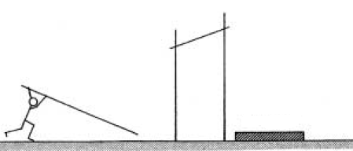
Figure 3.1
Landing mat

The centre of gravity of the athlete rises 4.2 m during the vault.
- Calculate the change in potential energy of the athlete between take off and reaching
the highest point.

change in potential energy = ………………J [2]

- Assuming that the centre of mass falls the same distance when falling, calculate
the vertical speed, in ms⁻¹, of the athlete when he lands.

vertical speed = ……………………ms⁻¹ [2]

- Explain how the landing mat reduces the force experienced by the athlete to an
acceptable level when landing.
…………………………………………………………………………………………
…………………………………………………………………………………….. [2]

- An object of mass 3.0 × 10³ kg is suspended from a steel cable of length 40 m and
cross-sectional area 1.0 × 10⁻⁴ m². Assume the cross-sectional area to be constant and
Young’s modulus for steel = 2.0 × 10¹¹ Pa. Determine the extension of the cable when
this mass-cable system

- is at rest

extension = ………………..…….m [2]

- moves upwards at constant speed

extension = ………….………..….m [1]

- moves upwards at constant acceleration of 3.0 ms⁻²

extension = …………………….m [2]

5. (a) Explain what is meant by interference.
…………………………………………………………………………………………
…………………………………………………………………………………………
……………………………………………………………………………………. [2]

(b) In the diagram below S₁ and S₂ are two continuous harmonic sound sources each of
which emit sound of wavelength 0.70m. As an instrument that detects sound intensity is moved along the line AB it registers a series of maximum sound intensities and minimum sound intensities.
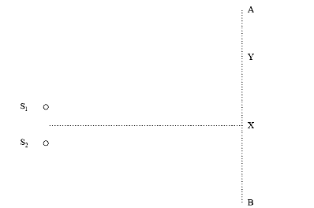

Fig 5

The first maximum registered is at X and the first minimum at Y.
The distance S₁X = S₂X.
- If the distance S₁Y is 3.0m what is the distance S₂Y equal to?
Explain your answer.
……………………………………………………………………………………..
………………………………………………………………………………… [2]

(ii) Describe and explain what will happen to the distance between the first
maximum and the first minimum if the frequency of the sound from the two
sources is increased.
………………………………………………………………………………………
………………………………………………………………………………….. [2]

- The sound waves in part (b) produce interference effects. If natural light is used instead, it does not produce observable interference effects. Explain why the loudspeakers are able to produce interference effects but the natural light do not.
………………………………………………………………………………………
………………………………………………………………………………… [2]
6. Imagine two equal masses, connected by a light rigid link, carrying equal but
opposite charges. This is a system called a dipole. Fig 6.1 and Fig 6.2 show the
dipole placed in different orientations between two uniformly and oppositely
charged plates.

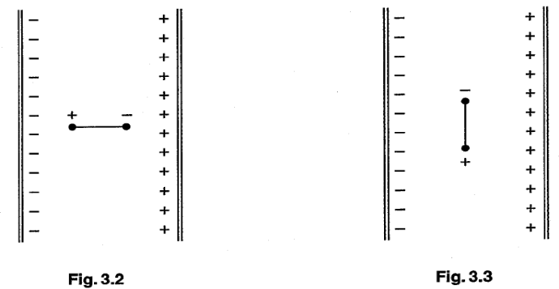
Fig 6.1 Fig 6.2

Any effect of gravity is negligible.

(a) Indicate the electric forces acting on the charges by drawing suitable arrows on the
Fig 6.1. [1]

Explain the motion, if any, of the dipole when it is released from rest
  - in Fig 6.1
…………………………………………………………………………………….
…………………………………………………………………………….… [2]

  - in Fig 6.2 ….………………………………………………………………………...……….
………………………………………………………………………...……… [2]

7. A set of Christmas lights has 46 lamps in a series circuit connected across the 230 V
mains. One of the lamps is shown in Fig 7.1.
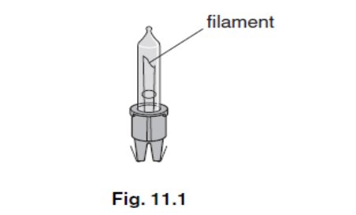
Fig 7.1

The p.d. against current relationship for the filament is shown in Fig 7.2.

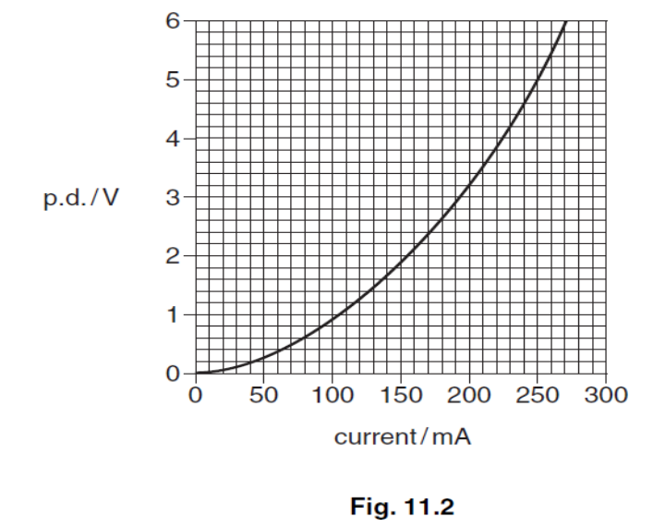
Fig 7.2

(a) Show that the potential difference across each lamp is 5V when lit normally.

potential difference = …………………. V [1]

(b) Calculate the resistance of each lamp filament when lit normally.

resistance = ………………………… Ω [2]

- In another set of 46 Christmas light the same lamps are used, but a 60 Ω resistor
in the lamp holder is connected in parallel with each lamp as shown in Fig 7.3.
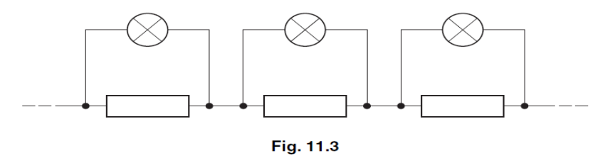
Fig 7.3

  - Suggest a reason for this design with a resistor in parallel with each filament.

………………………………………………………………………………… [1]

2. Calculate the current drawn from the mains supply by this set of lamps.

Current = ……………………………. A [3]

3. The filament breaks in one of the lamps.
State and explain what will happen to the brightness of the other 45 lamps.
………………………………………………………………………………
………………………………………………………………………………
……………………………………………………………………….... [2]

(d) In another set of lights which are meant to be identical to the set in part (c) there
is a manufacturing fault. The 60 Ω resistor has been omitted from one of the
lamp holders.
Suggest and explain what will happen to the brightness of the lamp in the holder
compared to the other 45 lamps.
……………………………………………………………………………………..………………………………………………………………………………………………………………………………………………………………………… [2]

- (a) Fig 8.1 shows the apparatus used to investigate Rutherford scattering, in which α particles are fired at a gold foil.
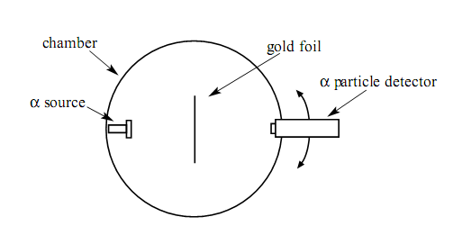

Figure 8.1

- Why is it essential for there to be a vacuum in the chamber?
……………………………………………………………………………………...
…………………………………………………………………………………. [1]

- What observations made with this apparatus support each of the following conclusions? No explanation is required.

    - The nuclear radius of gold is much smaller than its atomic radius. ……………………………………………………………………………… [1]

    - Most of the mass of an atom of gold is contained in its nucleus. ……………………………………………………………………………… [1]

      - Fig. 8.2 shows α particles incident on a layer of atoms in a gold foil.
On this figure draw the complete path followed by each of the α particles shown.
[3]
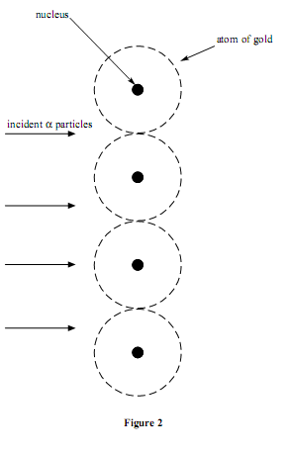
atom of gold
incident α particles
nucleus
Fig 8.2
nucleus

